Optimizing SecureBank’s fraud detection

An Assignment submitted in partial fulfillment of the requirements for the degree of
Bachelor of Science
in
Computer Science

CS 3303: Data Structures
Term 2 - 2025
University of The People

10th December, 2025

Optimizing SecureBank’s fraud detection
1. (a) Explain tree traversal and how it improves structuring and retrieving flagged transactions
Tree traversal is a systematic method for visiting each node within a hierarchical structure, such as a Binary Search Tree (BST), which is highly relevant for SecureBank’s fraud detection system. By organizing transaction data in a BST, analysts can efficiently structure and retrieve flagged transactions. For example, if high-risk transactions are inserted based on their risk score, traversing the BST allows the system to quickly access and review those that require immediate investigation. In the context of fraud detection, this structured approach ensures that analysts do not need to manually scan unordered lists, but instead can rely on traversal algorithms to process transactions in an organized fashion. This not only speeds up the identification of suspicious patterns, such as unauthorized access or rapid multiple transfers, but also streamlines the process of removing or investigating flagged transactions. The inherent hierarchical nature of trees, where each node connects to child nodes, supports efficient data organization, searching, and retrieval, allowing SecureBank to respond swiftly to potential fraud, minimizing losses, and improving operational resilience.
1.(b) Compare Pre-Order, In-Order, and Post-Order traversals
Pre-order, in-order, and post-order traversals each offer distinct advantages for fraud monitoring at SecureBank. Pre-Order traversal processes the root transaction first, followed by its left and right subtrees. This approach is ideal for quickly reviewing flagged cases at the top of the risk hierarchy, ensuring immediate attention to the most critical transactions. In-order traversal, which visits the left subtree, then the root, and finally the right subtree, is especially valuable for analyzing transaction history in sorted order. If the BST is organized by transaction time or value, In-order traversal produces a chronological or value-based list, making it easier to detect unusual patterns like high-value withdrawals. Post-order traversal, which processes subtrees before the root, is useful for bottom-up analysis, such as safely deleting flagged transactions after their children have been reviewed, or evaluating the cumulative risk within branches of the transaction history. By applying these traversal techniques, SecureBank’s AI-driven system can prioritize urgent cases, perform thorough reviews, and maintain an optimized monitoring process, greatly enhancing fraud detection capabilities.
1.(c) SecureBank’s AI-driven system
SecureBank’s AI-driven fraud detection system can leverage tree traversal techniques within a BST to effectively prioritize and analyze high-risk transactions. By storing transaction records as nodes in a BST, with attributes such as risk score or transaction value determining node order, the system can quickly locate and process the most suspicious activities. For example, an in-order traversal enables systematic examination of transactions from lowest to highest risk, while a reverse in-order traversal can prioritize the highest risk cases first. When a flagged transaction, such as a large withdrawal or a rapid series of transfers, is inserted, it is positioned according to its risk, allowing immediate access during traversal. If investigators need to remove a transaction after review, BST operations ensure the structure remains efficient for future searches. This organization allows SecureBank to rapidly identify patterns like unauthorized access from different locations. By structuring transaction data and applying targeted traversals, analysts can minimize delays in fraud detection and respond swiftly to emerging threats.
Question 2: BST search, insertion, and deletion
BST structure:
The BST is organized by risk scores, as shown below, making it efficient to find transactions within specific risk ranges. Lower risk scores are stored in the left subtree, and higher risk scores in the right subtree.
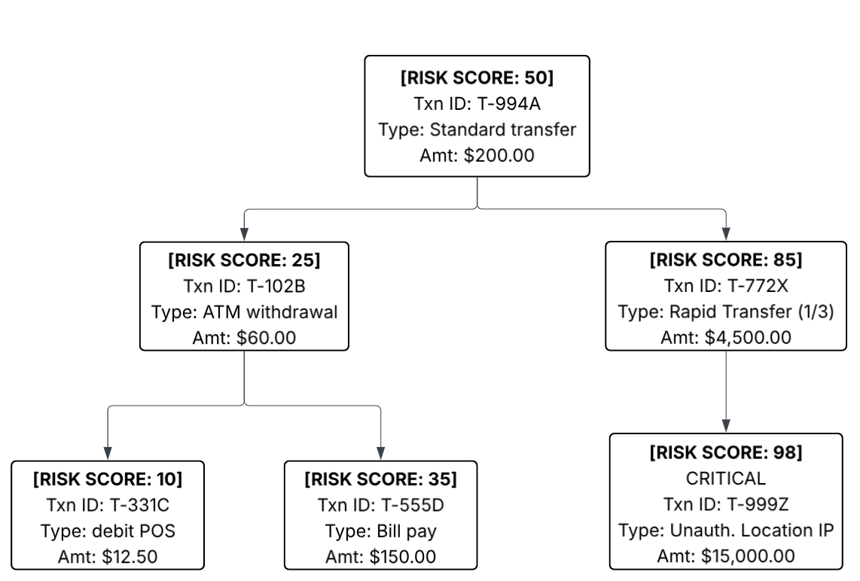

Insertion (O(h) time complexity, where h is the height of the tree):
New transactions are inserted based on their risk scores. If two transactions have the same risk score, the new one is added to the right subtree. This maintains the BST property where left < root < right based on risk scores.
Search (O(n) time in worst case for transaction ID search):
The search by transaction ID is implemented using a full tree traversal since transaction IDs aren't used for ordering. For large trees, this would be inefficient compared to a hash table, but it's necessary for the BST structure.
Deletion (O(h) time complexity):
- Leaf node: Simply remove the node.
- One child: Remove the node and link its parent to its child.
- Two children: Find the inorder successor (smallest in the right subtree), replace the node's data with the successor's data, and then delete the successor.
Impact on fraud detection:
- Efficient risk-based queries: The BST allows for efficient range queries to find transactions within specific risk thresholds.
- Ordered traversal: In-order traversal provides transactions sorted by risk score, making it easy to identify high-risk transactions.
- Deletion impact: Deleting a leaf node is simple and doesn't affect the overall structure. Deleting a node with one child maintains the BST property by linking the parent to the child. Deleting a node with two children maintains the BST property by replacing it with its inorder successor.
Comparison with unordered list:
- Search: O(n) for both, but BST can be optimized with additional structures for transaction ID lookup.
- Insertion: O(1) for list (at end), O(h) for BST.
- Deletion: O(n) for list (to find the element), O(h) for BST. Ordered Traversal: O(n log n) for list (requires sorting), O(n) for BST. This implementation provides an efficient way to manage and analyze potentially fraudulent transactions, with operations that scale well with the number of transactions.

